# Worksheet 3 – Polya

The maths needed in this worksheet is add ( 1+2 ), subtract ( 4-2 ), multiply ( 3*4 ) and divide ( 10/2 )

Reference code:

|  |  |
| --- | --- |
|  |  |

The print command is a strange beast. It will take multiple parameters, each separated with a comma:

Print has placed a single space between each of the parameters, and a new-line at the end.

Print will convert a number to a string before it prints it out:

As you can see with the numbers 1, 2 and 3.

But what happens if we don’t want the spaces in between the items, we want to take total control of the output?

Attempt 1:

Python has used string concatenation to append the three strings together into “ABC” which is then sent to the print command.

Attempt 2:

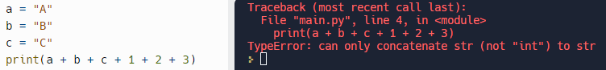

This fails because when Python attempts to determine what the + should do (is it string concatenation or is it a mathematical addition?) it can’t figure it out.

To fix this we need to cast the integers into strings using the str() command:

This has sent a single string to the print command.

If we compare that to the previous code that sent 6 parameters to the print command:

You can see how the output is different.

And finally I’m sending 3 different parameters to the print command (note where the commas are):

## Questions

Explain the difference between:

* 3
* 3.0
* “3”

## Coding Task 1

* ***Research*** the Python power operator **
* A computer program that asks a user to input two whole numbers
* It should display the square of each number
* Each number should be stored in sensibly named variables
* The program should contain comments throughout
* Use a multi-line comment at the start of the code to inform the reader of what the program is designed to achieve.

Follow Poylas 4 steps to solve the task. Document your progress:

## Coding Task 2

Create a program that allows the user to convert from mpg (m/g) to kilometres per litre (km/L)  
(miles * 1.609 ) / 3.785  
30 mpg is equal to 12.753 km/L  
<https://www.youtube.com/watch?v=tCkNhshfXrU>

Follow Poylas 4 steps to solve the task. Document your progress: